CS1A Problem Set 3

Programming Exercises

Problem 1:

Source Code:

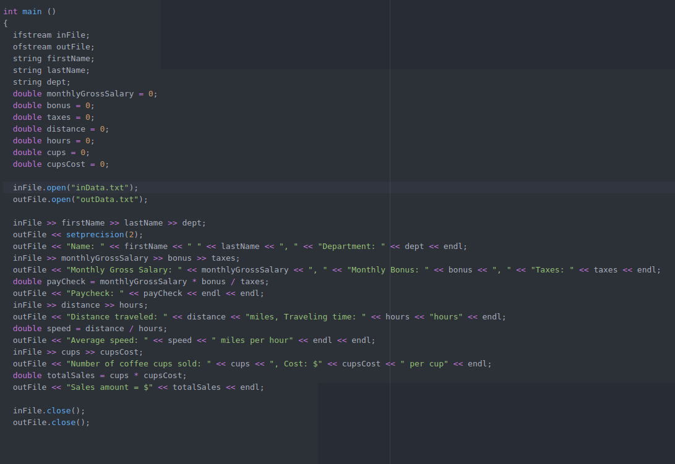

Output:

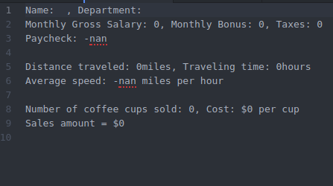

**Problem 2:**

**Sample Run:**

Enter the height of the cylinder: 15

Enter the radius of the base of the cylinder: 5

Volume of the cylinder = 1178.10

Surface Area: 628.32

**Pseudocode:**

Int main()

{

SET height 🡨 0;

SET radius 🡨 0;

INIT PI 🡨 3.14159

PRINT “Enter the height of the cylinder”

INPUT height

PRINT “Enter the radius of the base of the cylinder”

INPUT radius

PRINT “Volume of the cylinder is “ PI * pow(radius, 2.0) * height

PRINT “Surface area: “ 2 * PI * radius * height + 2 * PI * pow(radius , 2.0)

}

**Source code:**

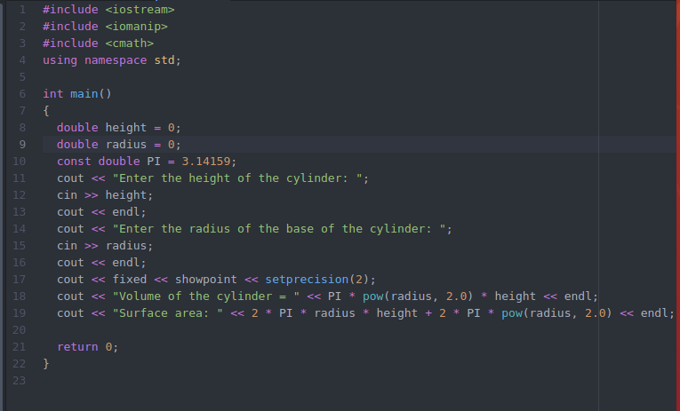

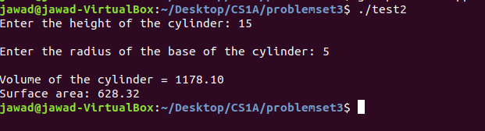**Output:**

**Problem 3**

**Sample Run:**

Please enter your weight in kilograms to get yout equivalent weight in Lbs: 80

Your weight in pounds is: 176.00

THANK YOU GOODBYE

**Pseudocode:**

Int main()

{

SET weightInKg 🡨 0;

SET weightInLbs 🡨 0;

PRINT “Please enter your weight in kilograms to get your equivalent weight in Lbs”

INPUT weightInKg

weightInLbs = weightInKg * 2.2

PRINT “Your weight in pounds is : “ weightinLbs

PRINT “THANK YOU GOODBYE!”

**Source code:**

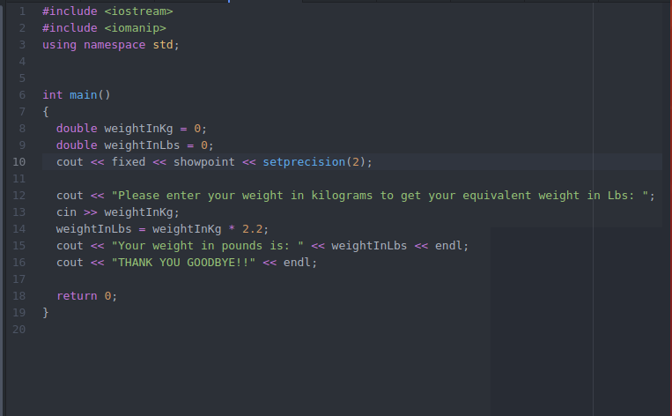

**Output:**

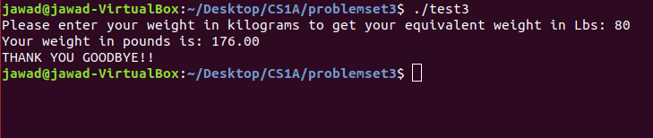

**Problem 4**

**Source Code:**

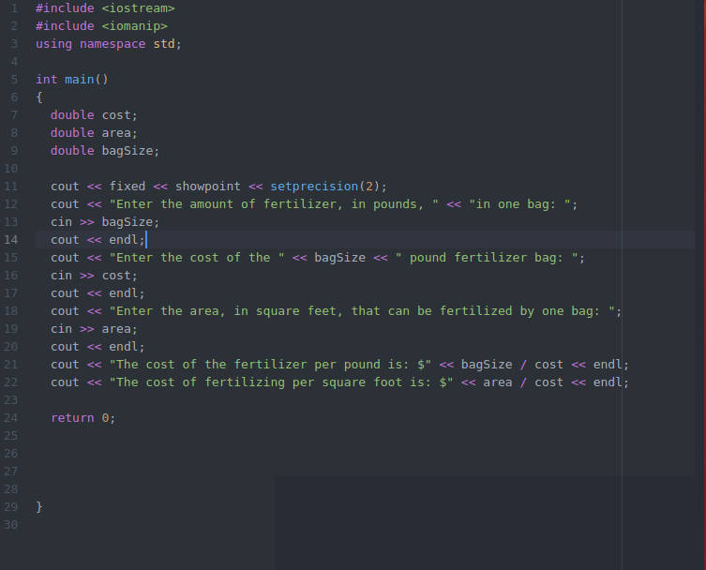

Corrected Logic Errors:

Line 21: calculation should be cost / bagSize

Line 22: calculation should be cost / area

**Problem 5**

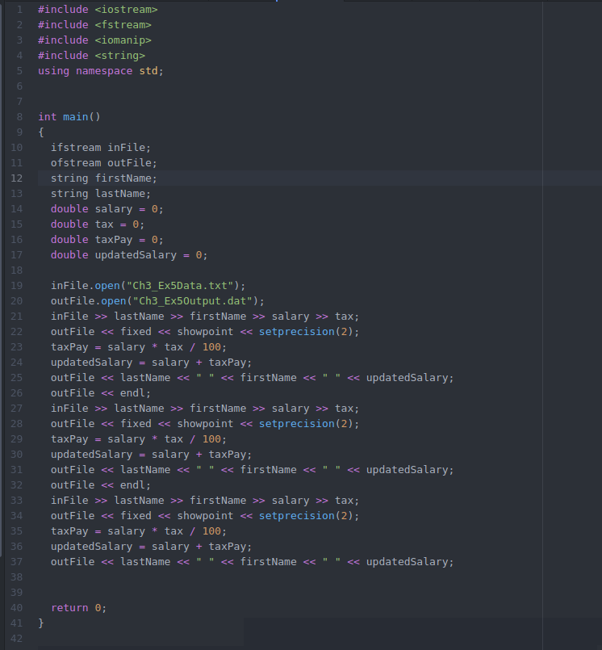

**Output:**

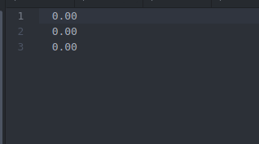

**Problem 6**

**Sample run:**

Welcome! Please enter the mass in grams and density of your object to find its volume!

Mass in grams: 25

Density: 9

The volume of your object is 2.78

**Psuedocode:**

Int main()

{

SET massINGrams 🡨 0;

SET density 🡨 0;

SET volume 🡨 0;

PRINT “Welcome! Please enter the mass in grams and density of your object to find its volume!

PRINT “Mass in grams: “

INPUT massInGrams

PRINT “Density: “

INPUT density

Volume 🡨 massInGrams / density

PRINT “The volume of your object is: “ volume

Source Code:

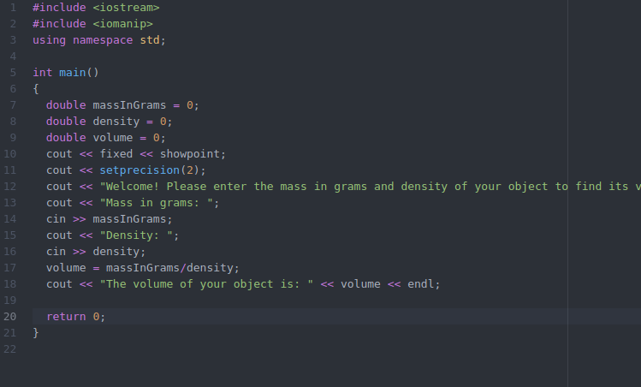

Output:

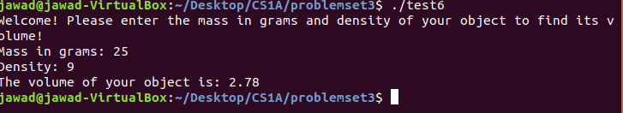

**Problem 7**

**Sample run:**

Please enter your net balance: 25000

Please enter the amount you would like to pay off: 500

Please enter the number of days in your billing cycle: 30

Please enter the number of days remaining on your bill cycle: 12

Your average daily balance is: 24800.00

The interest on the credit cards unpaid balance is $376.96

**Pseudocode:**

SET netBalance 🡨 0;

SET payment 🡨 0;

SET d1 🡨 0;

SET d2 🡨 0;

SET averageDailyBalance 🡨 0;

SET monthlyInterest 🡨 0.0152;

SET Interest 🡨 0 ;

PRINT “Please enter your net balance: “

INPUT netBalance

PRINT “Please enter the amount you would like to pay off”

INPUT payment

PRINT “Please enter the number of days in your billing cycle”

INPUT d1

PRINT “Please enter the number of days remaining on your bill cycle:

INPUT d2

averageDailyBalance 🡨 ((netBalance * d1) – (payment * d2)) / d1

interest 🡨 averageDailyBalance * monthlyInterest

PRINT “ Your average daily balance is” averageDailyBalance

PRINT “The interest on the credit cards unpaid balance is” interest

Source Code:

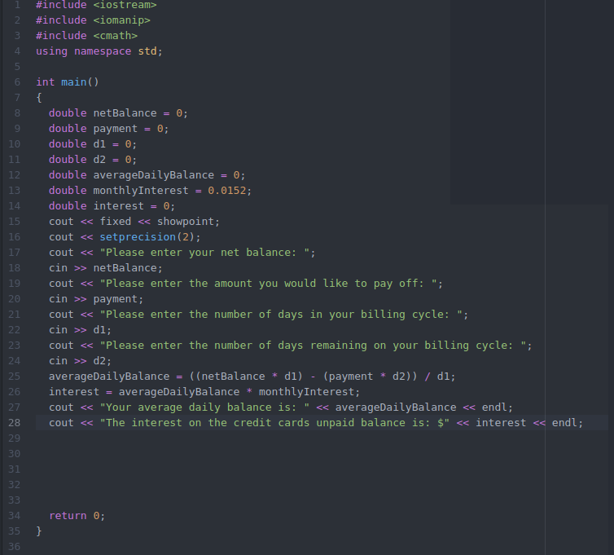

Output:

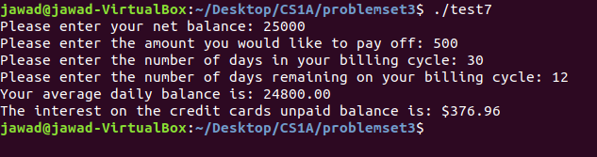

**Problem 8**

**Sample run:**

Please enter the total cost of the merchandise: 800

Enter employee salary: 15000

Enter yearly rent: 5000

Please enter the estimated electricity cost: 4000

The new markup cost is: 7294.12

**Pseudocode:**

SET merchandiseCost 🡨 0;

SET employeeSalary 🡨 0;

SET storeRent 🡨 0;

SET electricity cost 🡨 0;

SET totalExpenses 🡨 0;

SET costToGetToProfit 🡨 0;

SET totalCost 🡨0;

SET markUpCost🡨0;

PRINT “Please enter the total cost of the merchandise”

INPUT merchandiseCost

PRINT “Enter employee salary”

INPUT employeeSalary

PRINT “Enter the yearly rent”

INPUT storeRent

PRINT “Please enter the estimated electricity cost”

INPUT electricityCost

totalExpenses 🡨 merchandiseCost + employeeSalary + storeRent + electricityCost

costToGetProfit 🡨 totalExpenses + (totalExpenses * 0.10)

totalCost 🡨 costToGetProfit / (1.0 – 0.15)

marUpCost 🡨 totalCost – totalExpenses

PRINT “The new mark up cost is: “ markUpCost

**Source Code:**

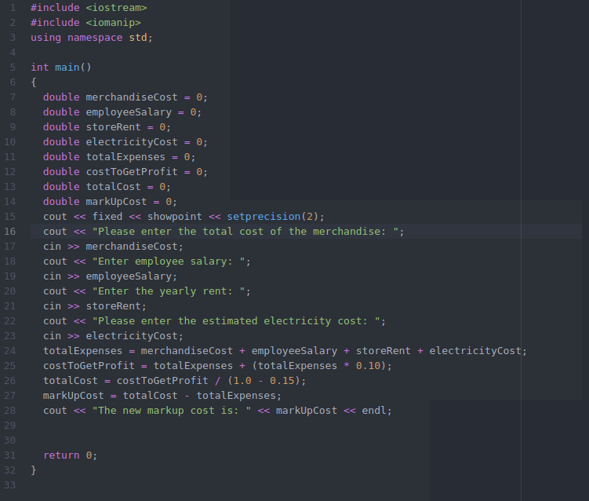

**Output:**

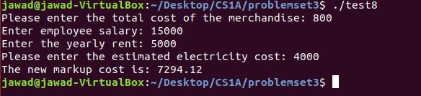

**Problem 9**

**Sample run:**

Please enter the radius of the base of the cylindrical container: 5

Please enter the height of the cylindrical container: 15

The volume of the container is: 1177.50

The side of the cube with the same volume as the cylindrical container is: 10.56

**Pseudocode:**

Int main()

{

SET radius 🡨 0;

SET height 🡨0;

SET side 🡨 0 ;

SET volume 🡨 0 ;

PRINT “Please enter the radius of the base of the cuylindrical container”

INPUT radius

PRINT “Please enter the height of the cylindrical container”

INPUT height

Volume 🡨 3.14 * radius * radius * height;

PRINT “The volume of the cylindrical container is: “ volume

Side 🡨 pow(volume, 1/3.0)

PRINT “The side of the cube with the same volume as the cylindrical container is: “ side

**Source code:**

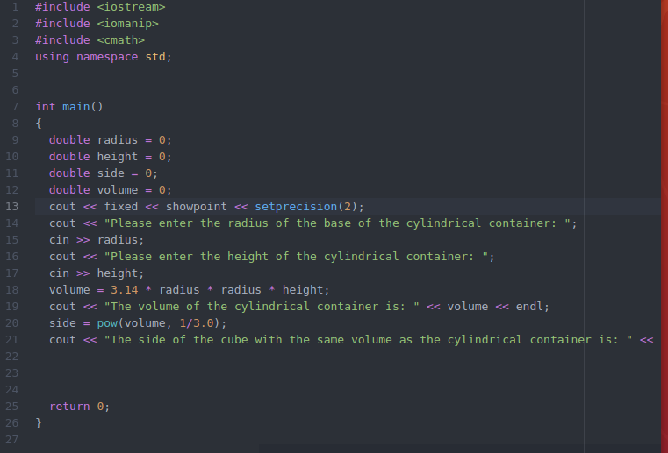

**Output:**

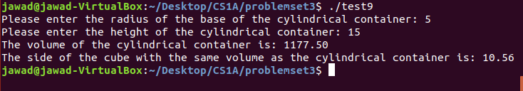

**Problem 10**

**Sample run:**

Enter the length of the yard: 100

Enter the radius of a fully grown tree: 10

Enter the space required between each tree: 20

The total number of trees is: 5

Total space occupied: 1570.00

**Pseudocode:**

Int main ()

{

SET length 🡨0;

SET radius 🡨 0;

SET spaceRequired🡨 0;

INIT trees 🡨 0;

PRINT “Enter the length of the yard”

INPUT length

PRINT “Enter the radius of a fully grown tree”

INPUT radius

PRINT “Enter the space required between each tree”

INPUT spaceRequired

Trees 🡨length / spaceRequired

PRINT “The total number of trees: “ trees

PRINT “Total space occupied: “ 3.14 * radius * radius * trees

**Source code:**

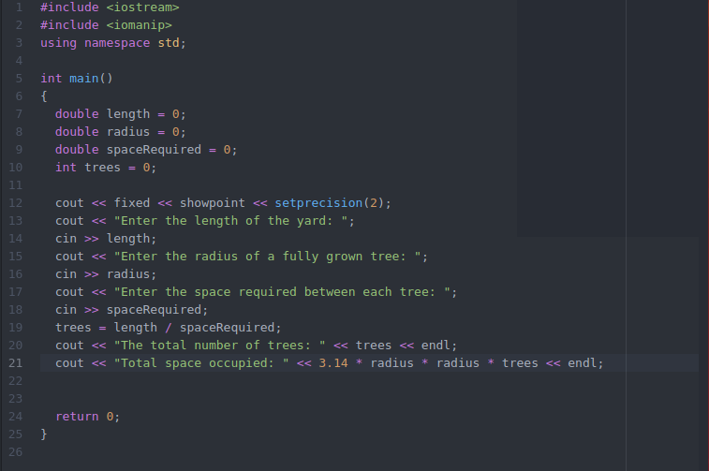

**Output:**

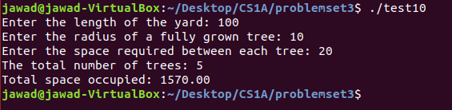

**Problem 11:**

**Sample run:**

Please enter the Length: 12

Please Enter the width: 7

Please enter the height: 3

Please enter the volume: 10

11.4 * 6.65 * 3

227.43

**Pseudocode:**

SET length 🡨 0;

SET width 🡨 0 ;

SET height 🡨 0 ;

SET p 🡨 0;

SET volume🡨 0;

PRINT “Please enter the length”

INPUT length

PRINT “Please enter the width”

INPUT width

PRINT “Please enter the height”

INPUT height

PRINT “Please enter the volume”

INPUT p

Length 🡨 length – (length * p/200)

width🡨 width – (width * p/200)

volume🡨 length * width * height

PRINT length “*” width “*” height

PRINT volume

**Source Code:**

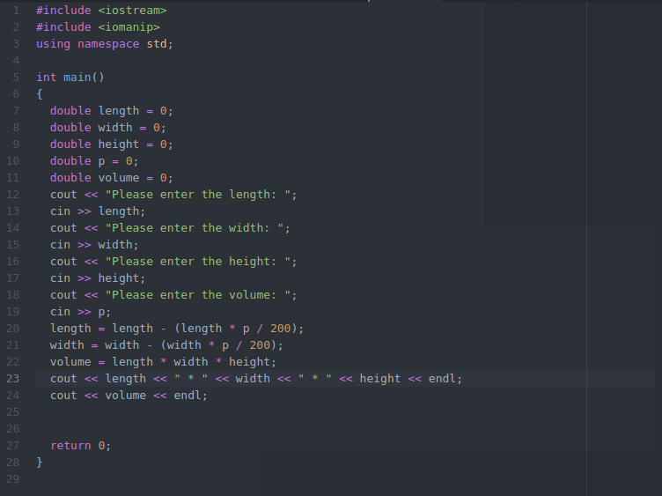

**Output:**

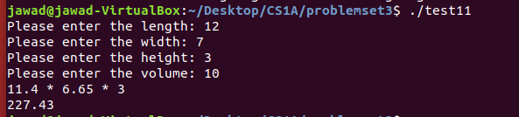

**Problem 12:**

**Sample run:**

Car A:

Enter the speed of Car A: 45

Enter the time elapsed for Car A: 1

Car B:

Enter the speed of Car B: 65

Enter the time elapsed: 3

The shortest distance between car A going west and car B going south is: 200.125

**Pseudocode:**

SET speedA🡨0;

SET timeA🡨0;

SET speedB🡨0;

SET timeB🡨0;

SET distanceA🡨0;

SET distance🡨0;

SET shortestDistance🡨0;

PRINT “Car A:”

PRINT “Enter the speed of car A:

INPUT speedA

PRINT “Enter the time elapsed for car A (Hours, Minutes): “

INPUT timeA

PRINT “Car B:”

PRINT “Please enter the speed of car B: “

INPUT speedB

PRINY “Enter the time elapsed for car B (Hours, minutes): “

INPUT timeB

distanceA🡨 speedA * timeA

distance 🡨 speedB * timeB

shortestDistance🡨 sqrt((distanceA * distance A) +( distance * distance))

PRINT “The shortest distance between car A going west and car B going south is: “ << shortestDistance

**Source code:**

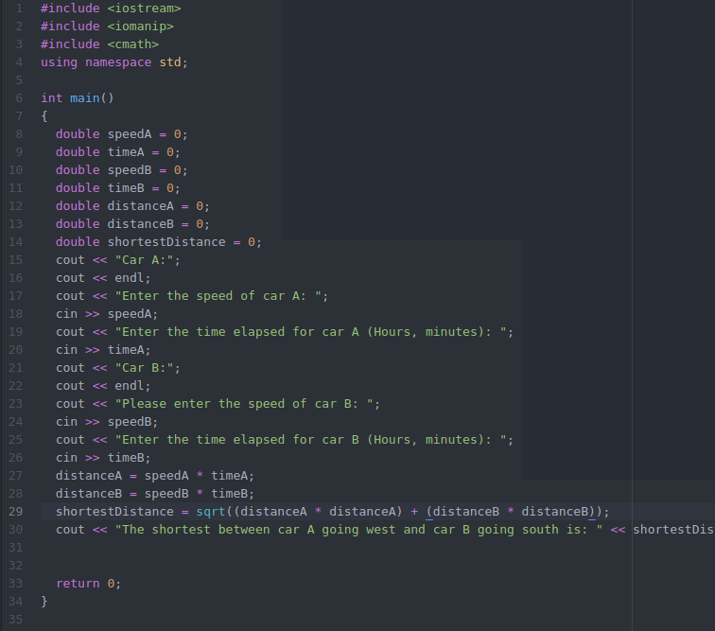

**Output:**

